**New Codington Festival Online Project -   
Wireframe**

**Project:** New Codington Festival Online Project

**System:**  FERS – Release 1

Table of Contents

1 Wireframe 2

# Wireframe

**Login**

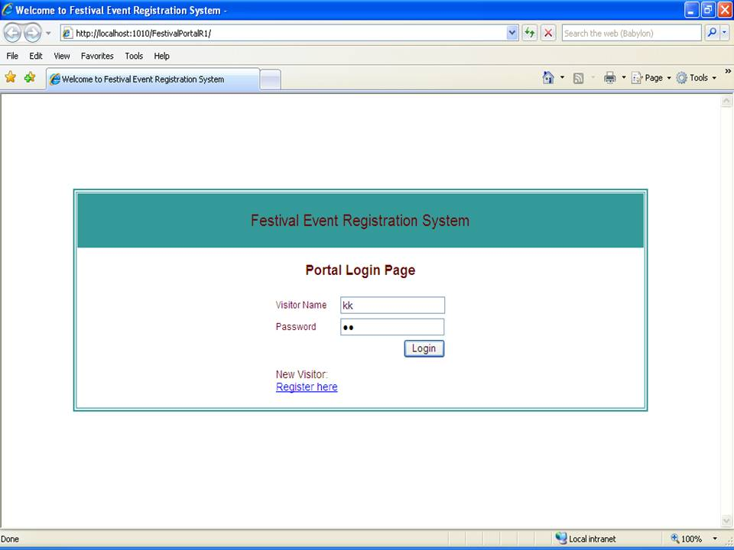

**Festival Portal**

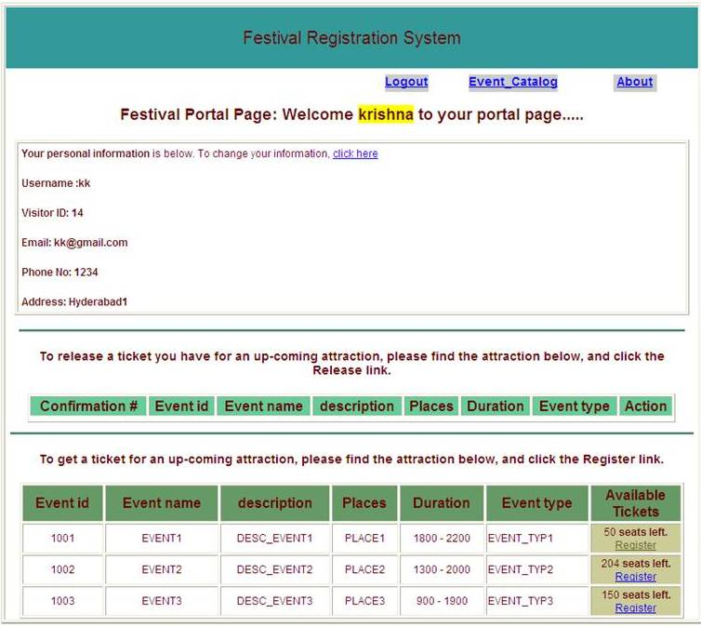

**Update Visitor’s Information Page**

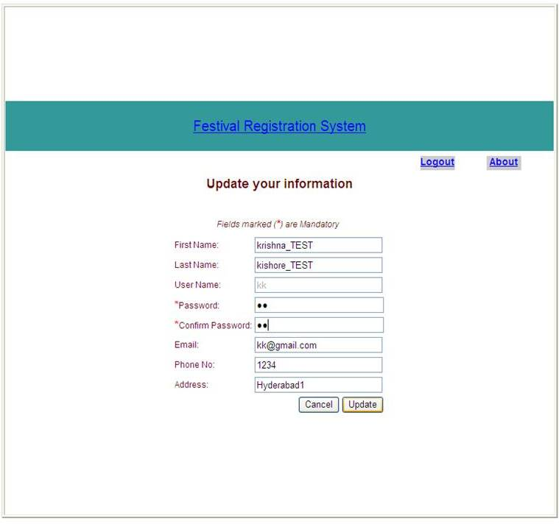

**Updated Visitor information – Confirmation Page**

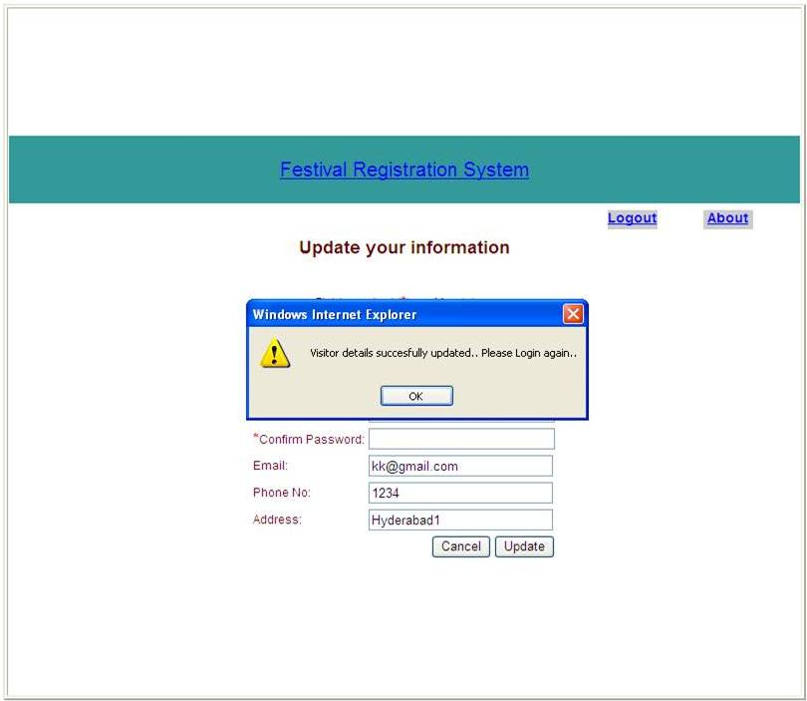

**Portal Page updated after successful Registration for an event**

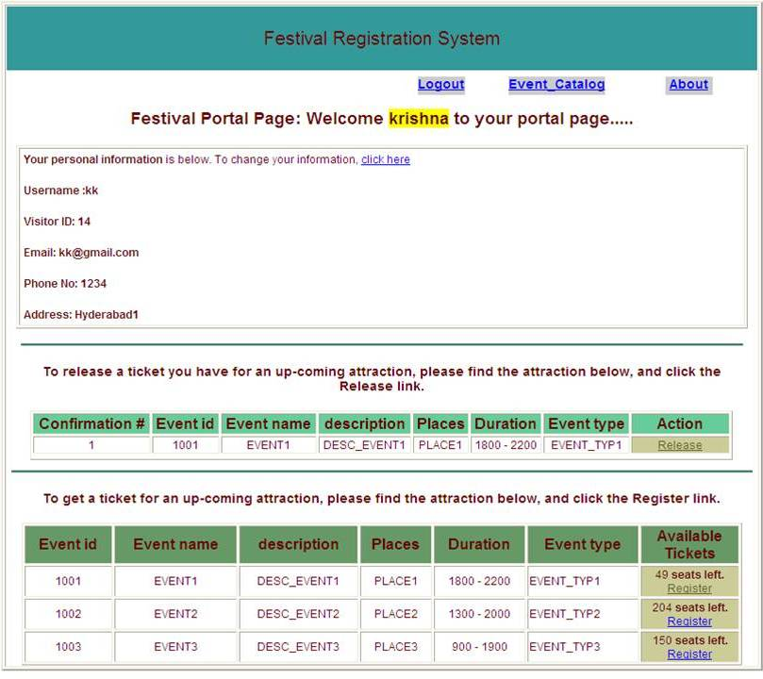

**Updated Portal Page after unregistering from an Event**

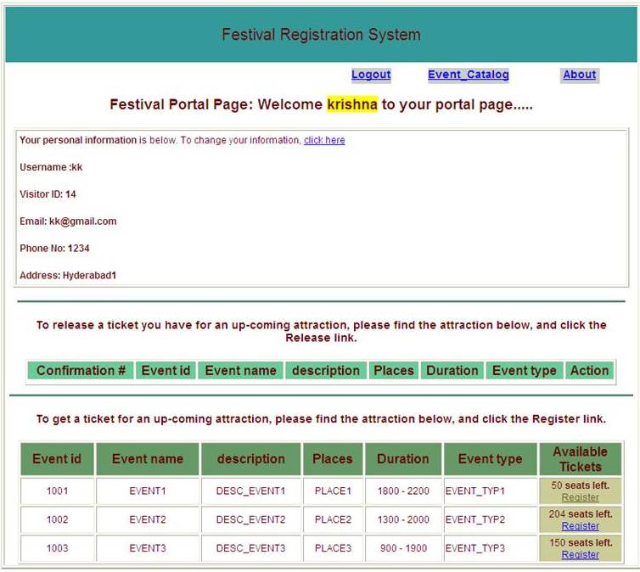

**Search (input parameters to be provided for Searching)**

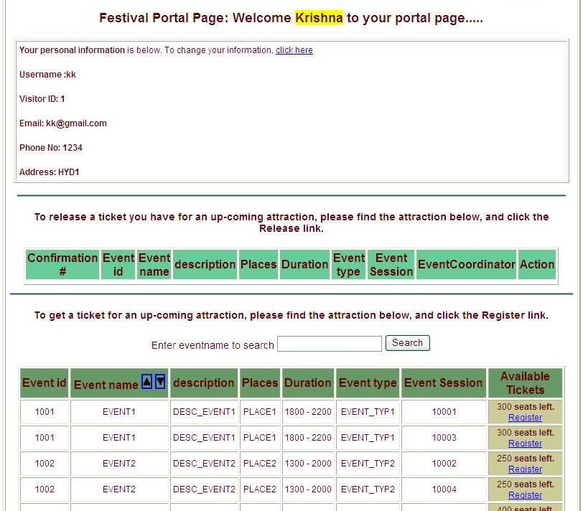

**Festival Portal page with Search Output**

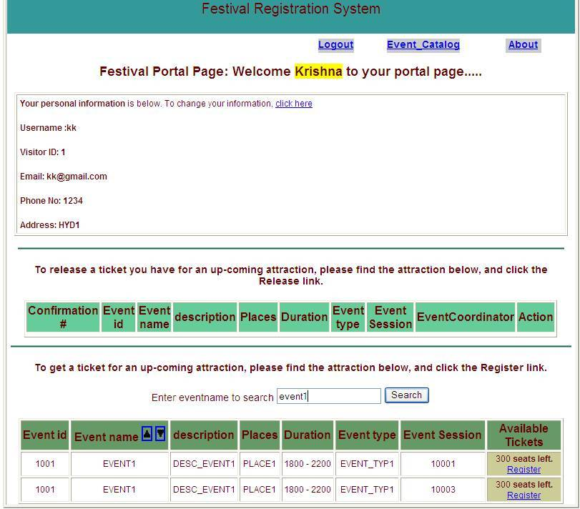

**Festival Portal Page with Sorted List of Events**

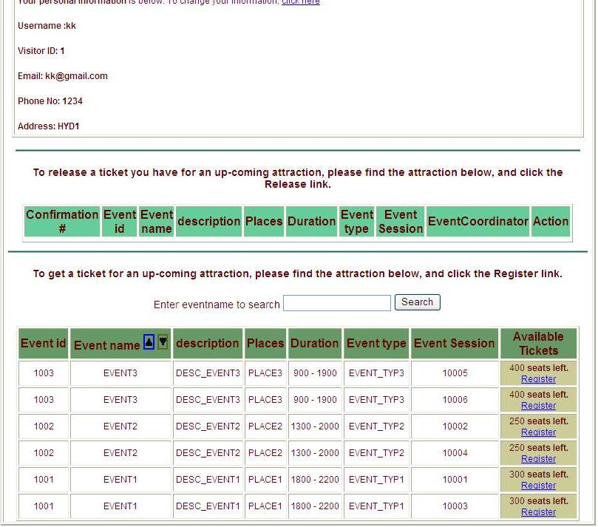

**Festival Portal Page with Event Catalog Page (Admin user)**

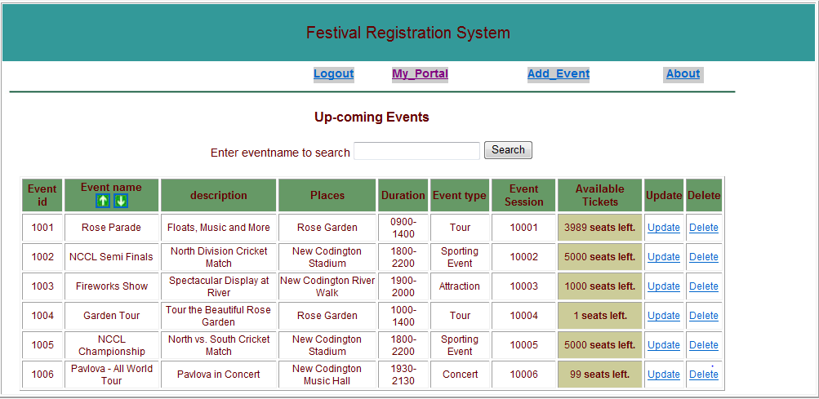

**Festival Portal Page with Add Event Catalog Page (Admin user)**

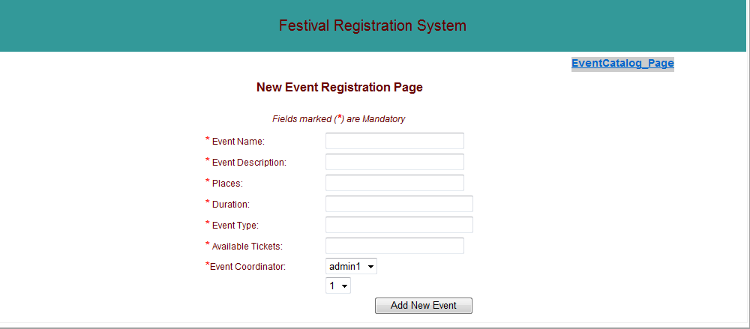

**Festival Portal Page with Update Event Catalog Page (Admin user)**

